Name:

Advait Vanne Roll No : 52/D14B

## Addition

### INPUT

#!/bin/bash

echo "Enter first number:" read num1

echo "Enter second number:" read num2

sum=$((num1 + num2)) echo "Sum: $sum" **OUTPUT**

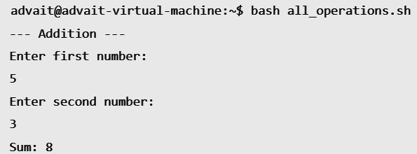

## Subtraction

### INPUT

#!/bin/bash

echo "Enter first number:" read num1

echo "Enter second number:" read num2

diff=$((num1 - num2)) echo "Difference: $diff" **OUTPUT**

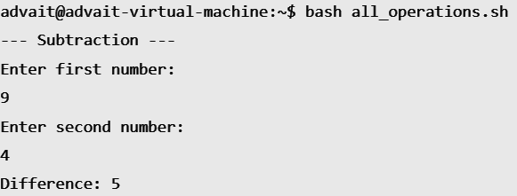

## Multiplication

### INPUT

#!/bin/bash

echo "Enter first number:" read num1

echo "Enter second number:" read num2

prod=$((num1 * num2)) echo "Product: $prod"

# OUTPUT

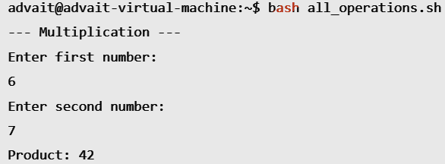

## Division

### INPUT

#!/bin/bash

echo "Enter first number:" read num1

echo "Enter second number:" read num2

if [ $num2 -eq 0 ]; then

echo "Error: Division by zero!" else

div=$((num1 / num2)) echo "Quotient: $div"

# OUTPUT

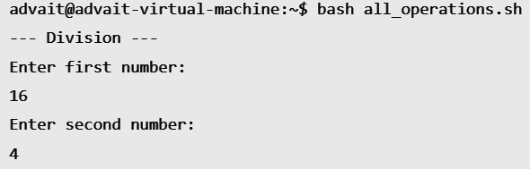

## Modulus

### INPUT

#!/bin/bash

echo "Enter first number:" read num1

echo "Enter second number:" read num2

mod=$((num1 % num2)) echo "Remainder: $mod" **OUTPUT**

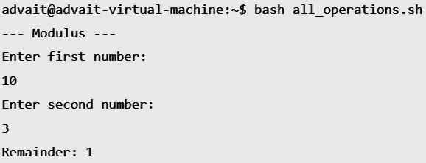

## FindLargestofTwoNumbers

### INPUT

#!/bin/bash

# Program to find the largest number echo"Enterfirstnumber:"

readnum1 echo"Entersecondnumber:" readnum2

if [ $num1 -gt$num2]; then echo"Largestnumber: $num1"

else

echo"Largestnumber: $num2"

fi

# OUTPUT

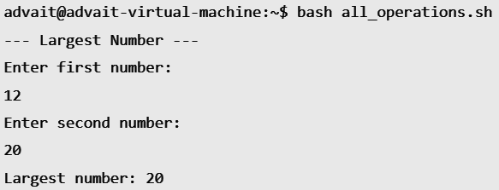

## FindSmallestofTwoNumbers

### INPUT

#!/bin/bash

# Program to find the smallest number echo"Enterfirstnumber:"

readnum1

echo"Entersecondnumber:" readnum2

if [ $num1 -lt$num2]; then echo"Smallestnumber: $num1"

else

echo"Smallestnumber: $num2"

fi

# OUTPUT

# 

## CheckOddorEven

### INPUT

#!/bin/bash

echo "Enter a number:" read num

if [ $((num % 2)) -eq 0 ]; then echo"Even"

else

echo"Odd"

fi

# OUTPUT

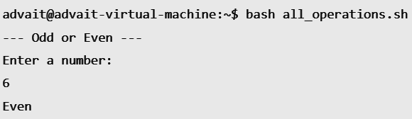

## Factorial

### INPUT

#!/bin/bash

echo "Enteranumber:" readnum

fact=1

for((i=1; i<=num; i++)) do

fact=$((fact* i)) done

echo"Factorial: $fact"

# OUTPUT

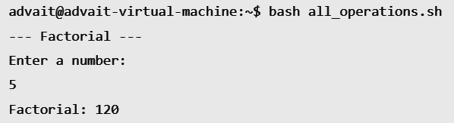

## PrimeNumberCheck

### INPUT

#!/bin/bash

echo "Enter a number:" read num

is_prime=1

for ((i=2; i<=num/2; i++)) do

if [ $((num % i)) -eq 0 ]; then is_prime=0

Break fi

done

if [ $is_prime -eq 1 ]; then echo "Prime"

else

echo "Not prime"

fi

# OUTPUT

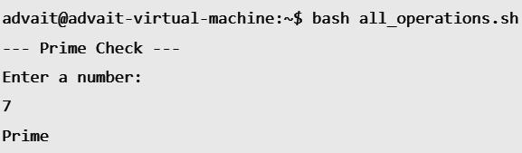

## Fibonacci Sequence

### INPUT

#!/bin/bash

echo "Enter the number of terms:" read num

a=0 b=1

echo "Fibonacci sequence:" for ((i=0; i<num; i++))

do

echo -n "$a " fn=$((a + b)) a=$b

b=$fn done OUTPUT

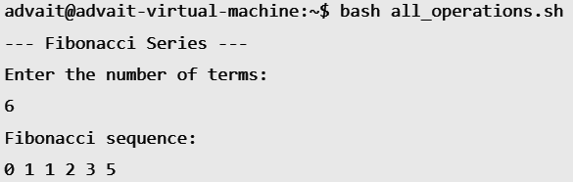

## Check Leap Year

### INPUT

#!/bin/bash

echo "Enter a year:" read year

if [ $((year % 4)) -eq 0 ] && [ $((year % 100)) -ne 0 ] || [ $((year % 400)) -eq 0 ]; then echo "Leap Year"

else

echo "Not a Leap Year" fi

# OUTPUT

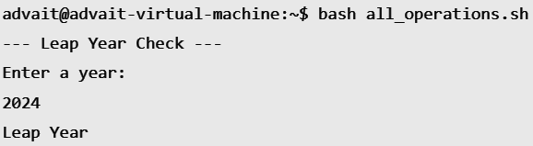

## Table of a Number

### INPUT

#!/bin/bash

echo "Enter a number:" read num

echo "Table of $num:" for ((i=1; i<=10; i++)) do

echo "$num * $i = $((num * i))" done

# OUTPUT

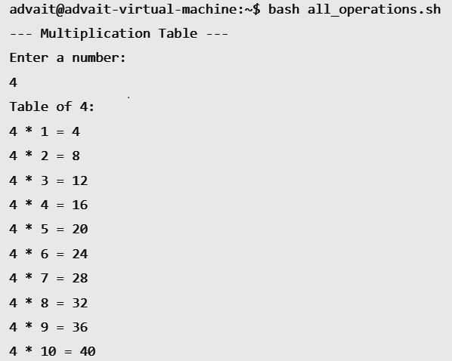

## Check Positive or Negative Number

### INPUT

#!/bin/bash

echo "Enter a number:" read num

if [ $num -gt 0 ]; then echo "Positive"

elif [ $num -lt 0 ]; then echo "Negative"

else

echo "Zero"

fi

# OUTPUT

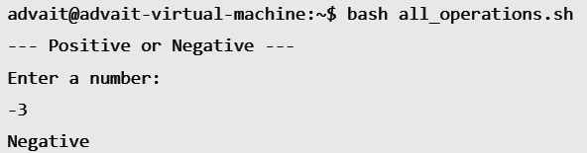

1. **Reverse a String**

### INPUT

#!/bin/bash

echo "Enter a string:" read str

rev_str=$(echo $str | rev)

echo "Reversed string: $rev_str"

# OUTPUT

# 

## Convert Celsius to Fahrenheit

### INPUT

#!/bin/bash

echo "Enter temperature in Celsius:" read celsius

fahrenheit=$(( (celsius * 9/5) + 32 )) echo "$celsius°C = $fahrenheit°F" **OUTPUT**

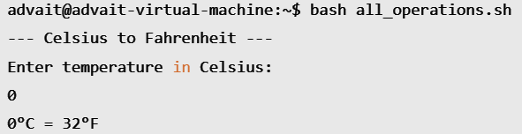

## Convert Fahrenheit to Celsius

### INPUT

#!/bin/bash

echo "Enter temperature in Fahrenheit:" read fahrenheit

celsius=$(( (fahrenheit - 32) * 5/9 )) echo "$fahrenheit°F = $celsius°C" **OUTPUT**

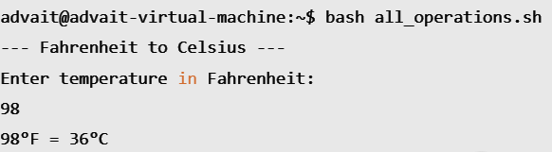

## Display Current Date and Time

### INPUT

#!/bin/bash

echo "Current Date and Time: $(date)"

# OUTPUT

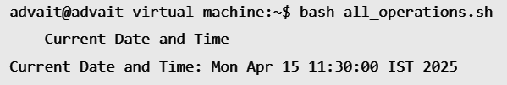

## Create a New File

### INPUT

#!/bin/bash

echo "Enter filename:" read filename

touch $filename

echo "File '$filename' created."

# OUTPUT

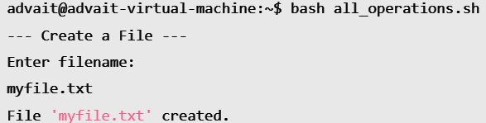

## Remove a File

### INPUT

#!/bin/bash

echo "Enter filename to remove:" read filename

rm $filename

echo "File '$filename' removed."

**OUTPUT**

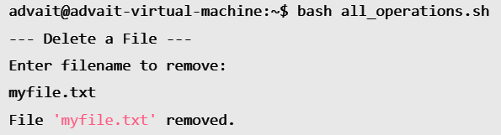

1. **Check Armstrong Number**

**INPUT:**

#!/bin/bash

echo "Enter a number:"

read num

temp=$num

sum=0

while [ $temp -gt 0 ]

do

digit=$((temp % 10))

sum=$((sum + digit * digit * digit))

temp=$((temp / 10))

done

if [ $sum -eq $num ]; then

echo "Armstrong Number"

else

echo "Not an Armstrong Number"

fi

**OUTPUT**:

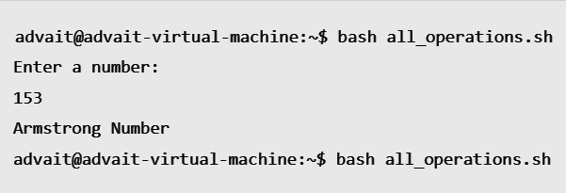

**22.Swap two numbers**

**INPUT:**

#!/bin/bash

echo "Enter first number:"

read a

echo "Enter second number:"

read b

temp=$a

a=$b

b=$temp

echo "After swapping: a=$a, b=$b"

**OUTPUT:**

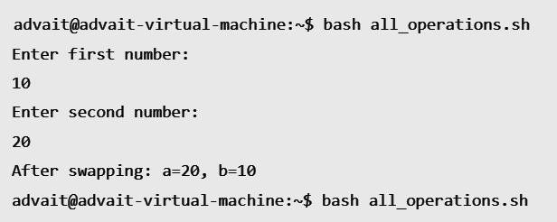

**23.Palindrome Number**

**INPUT:**

#!/bin/bash

echo "Enter a number:"

read num

temp=$num

rev=0

while [ $temp -gt 0]

do

digit=$((temp % 10))

rev=$((rev * 10 + digit))

temp=$((temp / 10))

done

if [ $rev -eq $num ]; then

echo "Palindrome Number"

else

echo "Not a Palindrome"

fi

**OUTPUT:**

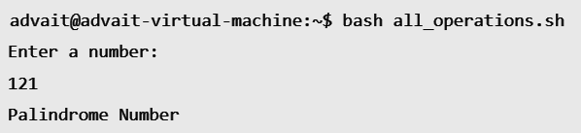

**24. Sum of Digits**

**INPUT:**

#!/bin/bash

echo "Enter a number:"

read num

sum=0

while [ $num -gt 0 ]

do

digit=$((num % 10))

sum=$((sum + digit))

num=$((num / 10))

done

echo "Sum of digits: $sum"

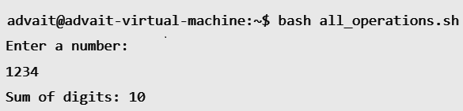

**25 . Reverse a Number**

**INPUT:**

#!/bin/bash

echo "Enter a number:"

read num

rev=0

while [ $num -gt 0 ]

do

digit=$((num % 10))

rev=$((rev * 10 + digit))

num=$((num / 10))

done

echo "Reversed Number: $rev"

**OUTPUT;**

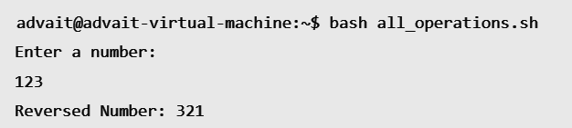

**26 Calculate Power**

**INPUT:**

#!/bin/bash

echo "Enter base:"

read base

echo "Enter exponent:"

read exp

result=1

for ((i=1; i<=exp; i++))

do

result=$((result * base))

done

echo "Power: $result"

**OUTPUT:**

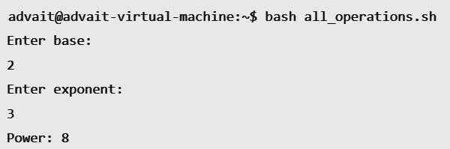

**27 Check Alphabet or Not**

**INPUT:**

#!/bin/bash

echo "Enter a character:"

read ch

if [[ $ch =~ [a-zA-Z] ]]; then

echo "Alphabet"

else

echo "Not an alphabet"

fi

**OUTPUT:**

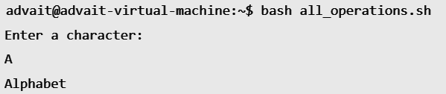

**28 Check Vowel or Consonant**

**INPUT:**

#!/bin/bash

echo "Enter a character:"

read ch

case $ch in

[aeiouAEIOU]) echo "Vowel" ;;

*) echo "Consonant" ;;

esac

**OUTPUT:**

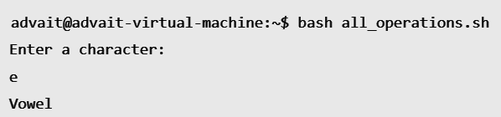

**29 Display Even Numbers (1 to 10)**

**INPUT:**

#!/bin/bash

echo "Even numbers from 1 to 10:"

for ((i=1; i<=10; i++))

do

if [ $((i % 2)) -eq 0 ]; then

echo $i

fi

done

**OUTPUT:**

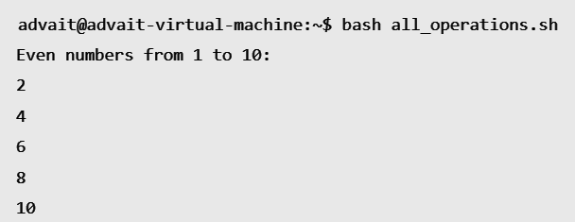

**30 Count Number of Digits**

**INPUT:**

#!/bin/bash

echo "Enter a number:"

read num

count=0

while [ $num -gt 0 ]

do

count=$((count + 1))

num=$((num / 10))

done

echo "Total digits: $count"

**OUTPUT:**

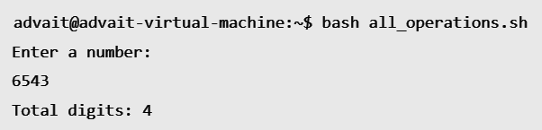

**31 Print Natural Numbers from 1 to N**

**INPUT:**

#!/bin/bash

echo "Enter a number:"

read n

echo "Natural numbers from 1 to $n:"

for ((i=1; i<=n; i++))

do

echo $i

done

**OUTPUT:**

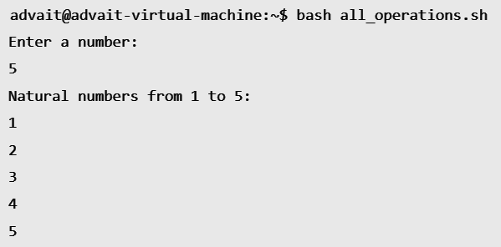

**32 Check Prime in a Range (1 to 10)**

**INPUT:**

#!/bin/bash

echo "Prime numbers from 1 to 10:"

for ((num=2; num<=10; num++))

do

is_prime=1

for ((i=2; i*i<=num; i++))

do

if (( num % i == 0 )); then

is_prime=0

break

fi

done

if (( is_prime == 1 )); then

echo $num

fi

done

**OUTPUT:**

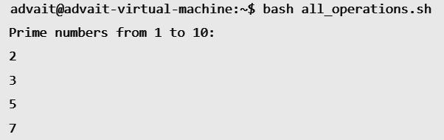

**33 Find Factorial Using Recursion**

**INPUT:**

factorial() {

if [ $1 -le 1 ]; then

echo 1

else

prev=$(factorial $(( $1 - 1 )))

echo $(( $1 * prev ))

fi

}

echo "Enter a number:"

read n

echo "Factorial: $(factorial $n)"

**OUTPUT:**

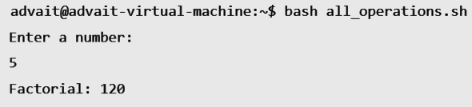

**34 Sum of First N Natural Numbers**

**INPUT:**

#!/bin/bash

echo "Enter a number:"

read n

sum=0

for ((i=1; i<=n; i++))

do

sum=$((sum + i))

done

echo "Sum: $sum"

**OUTPUT:**

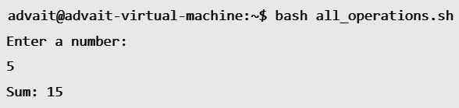

**35 Find LCM of Two Numbers**

**INPUT:**

#!/bin/bash

echo "Enter two numbers:"

read a b

max=$(( a > b ? a : b ))

while true

do

if (( max % a == 0 && max % b == 0 )); then

echo "LCM: $max"

break

fi

((max++))

Done

**OUTPUT:**

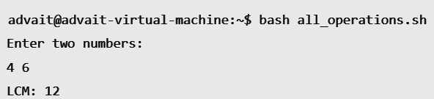

**36 Find HCF of Two Numbers**

**INPUT:**

#!/bin/bash

echo "Enter two numbers:"

read a b

while [ $b -ne 0 ]

do

temp=$b

b=$((a % b))

a=$temp

done

echo "HCF: $a"

**OUTPUT:**

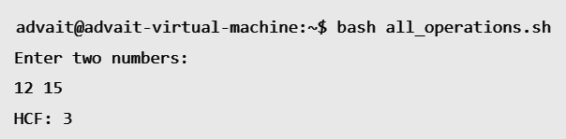

**37 Reverse a String**

**INPUT:**

#!/bin/bash

echo "Enter a string:"

read str

rev=$(echo "$str" | rev)

echo "Reversed string: $rev"

**OUTPUT:**

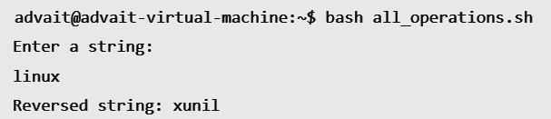

**38 Convert Lowercase to Uppercase**

**INPUT:**

#!/bin/bash

echo "Enter a string:"

read str

echo "Uppercase: ${str^^}"

**OUTPUT:**

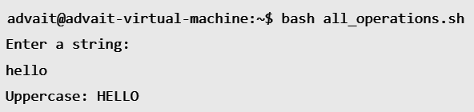

**39 Display Current User**

**INPUT:**

#!/bin/bash

echo "Current User: $USER"

**OUTPUT**:



**40 Display Number of Files in Directory**

**INPUT:**

#!/bin/bash

echo "Files in current directory: $(ls | wc -l)"

**OUTPUT:**

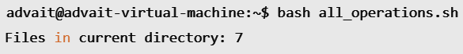

**41Check if File Exists**

**INPUT:**

#!/bin/bash

echo "Enter filename:"

read file

if [ -f "$file" ]; then

echo "File exists"

else

echo "File does not exist"

fi

**OUTPUT:**

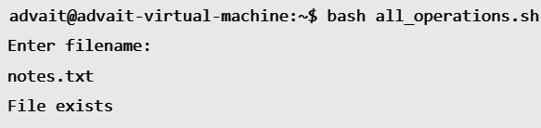

**42 Append Text to a File**

**INPUT:**

#!/bin/bash

echo "Enter filename:"

read file

echo "Enter text to append:"

read text

echo "$text" >> "$file"

echo "Text appended to $file"

**OUTPUT**:

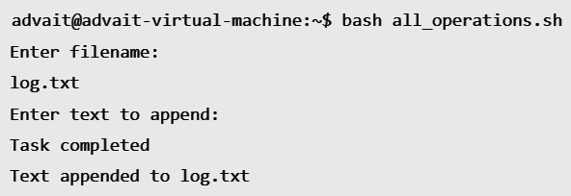

**43 Countdown Timer**

**INPUT:**

#!/bin/bash

echo "Enter countdown seconds:"

read sec

while [ $sec -gt 0 ]

do

echo $sec

sleep 1

((sec--))

done

echo "Time's up!"

**OUTPUT:**

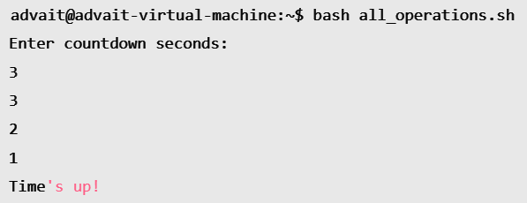

**44 Check Login Users**

**INPUT:**

#!/bin/bash

echo "Logged in users:"

who

**OUTPUT:**

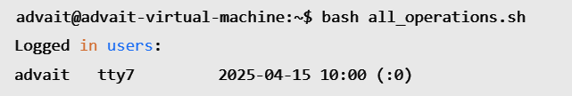

**45 Calculate Square of a Number**

**INPUT:**

#!/bin/bash

echo "Enter a number:"

read num

square=$((num * num))

echo "Square: $square"

**OUTPUT:**

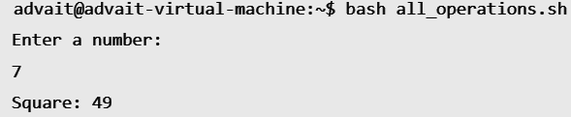

**46 Check Number is Positive, Negative, or Zero**

**INPUT:**

#!/bin/bash

echo "Enter a number:"

read num

if [ $num -gt 0 ]; then

echo "Positive"

elif [ $num -lt 0 ]; then

echo "Negative"

else

echo "Zero"

fi

**OUTPUT:**

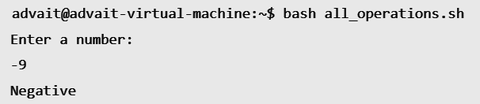

**47 Display Memory Usage**

**INPUT:**

#!/bin/bash

echo "Memory usage:"

free -h

**OUTPUT:**

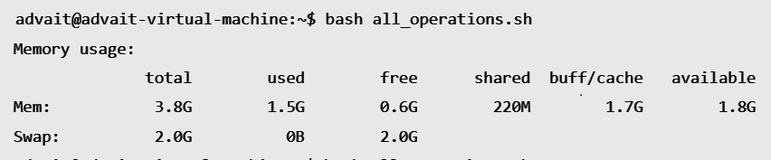

**48 Print Table of N**

**INPUT:**

#!/bin/bash

echo "Enter a number:"

read n

for ((i=1; i<=10; i++))

do

echo "$n * $i = $((n * i))"

done

OUTPUT:

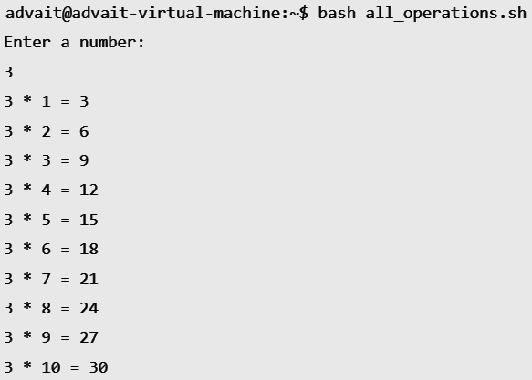

**49 Check Divisibility by 5 and 11**

**INPUT:**

#!/bin/bash

echo "Enter a number:"

read num

if (( num % 5 == 0 && num % 11 == 0 )); then

echo "Divisible by both 5 and 11"

else

echo "Not divisible by both"

fi

OUTPUT:

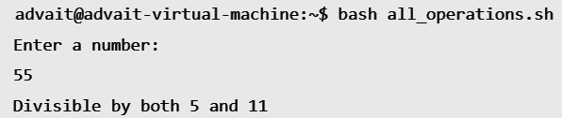

**50 Display Calendar**

**INPUT:**

#!/bin/bash

cal

**OUTPUT:**

